Solomon Islands

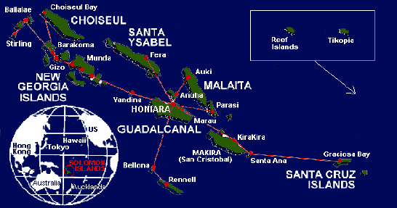
Official Name: Solomon Islands
Short form: Solomons
Former: British Solomon Islands
The Solomon Islands consist of six major and approximately 900 smaller volcanic islands, coral atolls and reefs, more than 300 of them are inhabited. They stretch about 900 miles in a south-easterly direction from Papau New Guinea toward Fiji. The former UK protectorate, established in the 1890s, is one of the poorest countries in the South Pacific; 85 percent of the country's population live in isolated rural villages on undeveloped outer islands.

History:
It is thought the Solomons were discovered and settled by the Austronesians about 5000 years ago. The Spanish were the first Europeans to visit the islands in 1568. The Island has been self governed since 1976. Some of the worst fighting in World War II took place in the Solomons.
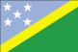
Flag:
Blue over green divided by a diagonal yellow band, with five white stars in the top left quarter
Capital City:
Honiara on the island of Guadalcanal with a population of around 30,000 in the city, with Guandalcanal having a population of around 100,000..
Government:
Type: Parliamentary democracy within the Commonwealth.
Chief of state: Queen ELIZABETH II (since 6 February 1952), represented by Constitution: May 1978.
Independence: 7 July 1978 (from the United Kingdom).
Geography:
Location: Oceania; group of South Pacfic islands east of Papua New Guinea.
Area: Land -- 27,556 sq. km. (11,599 sq. mi.). Archipelago--725,197 sq. km. (280,000 sq. mi.).
Terrain: rugged mountains with some low coral atolls.
Climate: Tropical with average daytime temperatures around 29 degrees and high humidity, monsoonal wet season occurring between November and March.
People:
Nationality: Solomon Islander(s).
Population (est. 2004): between 320 000 - 520 000.
Ethnic groups: Melanesian 93%, Polynesian 4%, Micronesian 1.5%, European 0.8%, Chinese 0.3%, other 0.4%
Religions: Christian 95%--more than one-third Anglican (Archdiocese of Melanesia), indigenous beliefs 4%. Other denominations include Bahai, Jehovah’s Witness and Seventh Day Adventists.
Languages: English and pidgin English (Solomon Island Pijin) ar the main languages but there are about 90 indigenous languages and dialects spoken throughout the islands.
Natural resources: Fish, forests, palm products (oil and kernels) as well as cocoa, gold, bauxite, phosphates, lead, zinc, nickel.
Currency:
Solomon Island dollars

Dress:
Casual cotton clothing is ideal with a sweater for the odd cool evening. Women should always dress modestly in public areas.

Food:
Local food includes seafood such as the coconut crab and lobster.

Customs:
National Anthem: God Bless the Solomon Islands
National Day: 7 July, Independence Day

Travel & Communications:
Solomon Airlines operate international services to other Pacific states and Australia Air flies from Port Moresby to Horesby to Honiara. There are about 52 miles of secondary and minor roads in the urban areas of Honiara, Auki and Gizo. In the rural areas there are some 800 miles of road, including those in private plantations, forestry areas and roads build and maintained by councils. Telekom operates the international and domestic telephone circuits from a ground station in Honiara via the Intelsat Pacific Ocean communication satellite.

Trade:
The main imports are foodstuffs, consumer goods, and machinery and transport materials. Principal exports are timber, fish, copra, and palm oil. Other exports include cocoa and marine shells.

Electricity:
The availability of electricity is at present confined to Honiara and five other urban centres.
For further information check out www.jasons.com
